**Topics: Normal distribution, Functions of Random Variables**

1. The time required for servicing transmissions is normally distributed with *μ* = 45 minutes and *σ* = 8 minutes. The service manager plans to have work begin on the transmission of a customer’s car 10 minutes after the car is dropped off and the customer is told that the car will be ready within 1 hour from drop-off. What is the probability that the service manager cannot meet his commitment?
2. 0.3875
3. 0.2676
4. 0.5
5. 0.6987

**ANSWER: 0.2676**

Explaination:

The work begin after 10 min, so the average time increase from 45min to 55min.

for normal distribution :-

z = (X-μ)/б

= (60-55)/8

= 0.625

In R software for probability finding we use function called pnorm

1-pnorm(60, mean=55, sd=8)

=0.2659

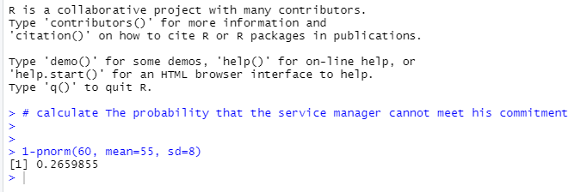

1. The current age (in years) of 400 clerical employees at an insurance claims processing center is normally distributed with mean *μ* = 38 and Standard deviation *σ* =6. For each statement below, please specify True/False. If false, briefly explain why.
2. More employees at the processing center are older than 44 than between 38 and 44.
3. A training program for employees under the age of 30 at the center would be expected to attract about 36 employees.

**Given :**The current age (in years) of 400 clerical employees at an insurance claims processing center is normally distributed with mean 38 & SD = 6

**Solution:**

**For A:**

Mean = 38

SD = 6

Z score = (Value - Mean)/SD

Z score for 44  = (44 - 38)/6  = 1  =  84.13 %

=> People above 44 age = 100 - 84.13 =  15.87%  ≈  63    out of 400

Z score for 38  = (38 - 38)/6 = 0 = 50%

Hence People between 38 & 44  age = 84.13 - 50 = 34.13 % ≈  137 out of 400

Hence More employees at the processing center are older than 44 than between 38 and 44. is F**ALSE**

Z score for 30  = (30 - 38)/6 =  -1.33  =  9.15  %   ≈ 36 out of 400

For B:

Hence A training program for employees under the age of 30 at the center would be expected to attract about 36 employees - **TRUE**

1. If *X1* ~ *N*(μ, σ2) and *X*2 ~ *N*(μ, σ2) are *iid* normal random variables, then what is the difference between 2 *X*1 and *X*1 + *X*2? Discuss both their distributions and parameters.

**Answer:-**

As we know that if *X1* ~ *N*(μ, σ2) and *X*2 ~ *N*(μ, σ2) are two independent random variable then X + Y ∼ N(µ1 + µ2, σ1^2 + σ2^2 ) , and X − Y ∼ N(µ1 − µ2, σ1^2 + σ2^2 ).

Similarly, if Z = aX+by, where X and Y are as defined above, i.e Z is linear combination of X and Y, then Z ∼ N(aµ1 + bµ2, a^2σ1^2 + b^2σ2^2 ).

Therefore in the question

2X1~ N(2 u,4 σ^2)

X1+X2 ~ N(µ + µ, σ^2 + σ^2 ) ~ N(2 u, 2σ^2 )

2X1-(X1+X2) = N( 4µ,6 σ^2)

1. Let X ~ N(100, 202). Find two values, *a* and *b*, symmetric about the mean, such that the probability of the random variable taking a value between them is 0.99.
2. 90.5, 105.9
3. 80.2, 119.8
4. 22, 78
5. 48.5, 151.5
6. 90.1, 109.9

**Answer:**

Two values symmetric about mean for the given standard normal distribution are[48.5,151.5]

Given:  p(a<x<b) = 0.99 ,m ean =100,standardDeviation = 20

To Find:

Identify symmetric values for the standard normal distribution such that the area enclosed is .99

From the above details,we have to excluded area of .005 in each of the left and right tails. Hence, we want to find the 0.5th and the 99.5th percentiles Z score values

Using Python

Z value is given as stats.norm.ppf(pvalue)

Z value at 0.5th percentile is given as

                                         Z(0.5) = stats.norm.ppf(0.005)= -2.576

Z value at 99.5 percentile is given as

                         Z(99.5) = stats.norm.ppf(0.995) = 2.576

Z = (x - 100)/20 = x = 20z+100

      a = -(20*2.576) + 100= 48.5

      b = (20*2.576)+100= 151.5

Two values symmetric about mean for the given standard normal distribution are[48.5,151.5]

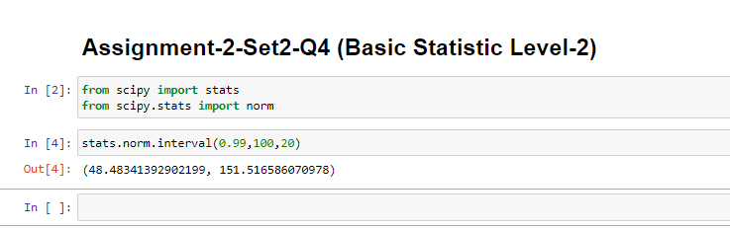

1. Consider a company that has two different divisions. The annual profits from the two divisions are independent and have distributions Profit1 ~ N(5, 32) and Profit2 ~ N(7, 42) respectively. Both the profits are in $ Million. Answer the following questions about the total profit of the company in Rupees. Assume that $1 = Rs. 45
2. Specify a Rupee range (centered on the mean) such that it contains 95% probability for the annual profit of the company.
3. Specify the 5th percentile of profit (in Rupees) for the company
4. Which of the two divisions has a larger probability of making a loss in a given year?

**Answer:**

A): **Range**containing 95% **probability**for **profit**of **company**is

(Rs. 99M, Rs. 1026M).

B): Rs. 170.1 Million.

C): First **division**of the **company**has larger **probability**of **making**a **loss.**

Given that:

$1 = Rs. 45

Profit1 ~ N(5,32)

Profit2 ~ N(7,42)

Thus,

**Company's profit**:

P ~ N (5+7, 32+42) = N (12, 52)

A):

95% of the **probability lies**between 1.96 **standard deviations**of the**mean.**

Thus **range**is:

= (12 – 1.96 * 5, 12 + 1.96 * 5)

= ($2.2M, $22.8M)

=(Rs. 99M, RS. 1026M)

B): **Fifth percentile**is calculated as:

P (z ≤ $\frac{ p-12}{5}$) = 0.05

From p **values**of z **score table**, we get:

= $\frac{p-12}{5}$

= -1.644

p = 12 – 8.22 = 3.78

Thus at $3.78M **dollars**, or Rs. 170.1M **amount,** 5th **percentile**of **profit lies.**

Or 5th **percentile**of **profit**is Rs. 170.1 Million.

C): Loss is when profit < 0

Thus: p < 0

The first **division** of **company**, thus have **larger probability**of making a loss in a given year.